Identification of cholesterol-assimilating actinomycetes strain and application of statistical modeling approaches for improvement of cholesterol oxidase production by Streptomyces anulatus strain NEAE-94
Noura El-Ahmady El-Naggar*, Nancy M. El-Shweihy
Department of Bioprocess Development, Genetic Engineering and Biotechnology Research Institute, City for Scientific Research and Technological Applications, Alexandria, Egypt

*To whom correspondence should be addressed.

Dr. Noura El-Ahmady Ali El-Naggar
Address:
Bioprocess Development Department,
Genetic Engineering and Biotechnology Research Institute,
City of Scientific Research and Technological Applications,
New Borg El- Arab City, 21934, Alexandria, Egypt
Tel: (002)01003738444
Fax: (002)03 4593423
E-mail: nouraelahmady@yahoo.com

Supplementary Table 1. Cultural properties of Streptomyces sp. strain NEAE-94
Medium | Color of |  |  | Growth
Medium | Diffusible pigment | Substrate mycelium | Aerial  mycelium | Growth
ISP 2 | Yellow | Yellow | Whitish yellow | Excellent
ISP 3 | Faint yellow | Yellow | Yellow | Excellent
ISP 4 | Yellow | Yellow | Yellow | Excellent
ISP 5 | Yellow | Faint orange | Faint yellow | Weak
ISP 6 | Non-pigmented | Faint orange | Faint yellow | Weak
ISP 7 | Yellow | Brownish orange | Yellow | Very good

Supplementary Table 2. Fit summary for Box-Behnken design results

Sequential Model Sum of Squares
Source | Sum of Squares | df | Mean Square |  | F-value |  | P-value  Prob >F
Linear vs Mean | 81.84 | 3 | 27.28 |  | 0.49 |  | 0.6986
2FI vs Linear | 52.84 | 3 | 17.61 |  | 0.25 |  | 0.8594
Quadratic vs 2FI | 560.74 | 3 | 186.91 |  | 275.33 |  | < 0.0001*
Residual | 1.04 | 2 | 0.52
Lack of Fit Tests
Source | Sum of Squares | df | Mean Square |  | F-value |  | P-value  Prob >F
Linear | 615.94 | 9 | 68.44 |  | 131.78 |  | 0.0076*
2FI | 563.10 | 6 | 93.85 |  | 180.71 |  | 0.0055*
Quadratic | 2.36 | 3 | 0.79 |  | 1.51 |  | 0.4219
Pure Error | 1.04 | 2 | 0.52
Model Summary Statistics
Source | Standard deviation | R-Squared |  | Adjusted R-Squared |  | Predicted R-Squared |  | PRESS
Linear | 7.49 | 0.1171 |  | -0.1237 |  | -0.3361 |  | 933.70
2FI | 8.40 | 0.1927 |  | -0.4127 |  | -0.9671 |  | 1374.66
Quadratic | 0.82 | 0.9951 |  | 0.9864 |  | 0.9427 |  | 40.03
* Significant values, “df : degree of freedom, PRESS: sum of squares of prediction error, two factors interaction: 2FI”

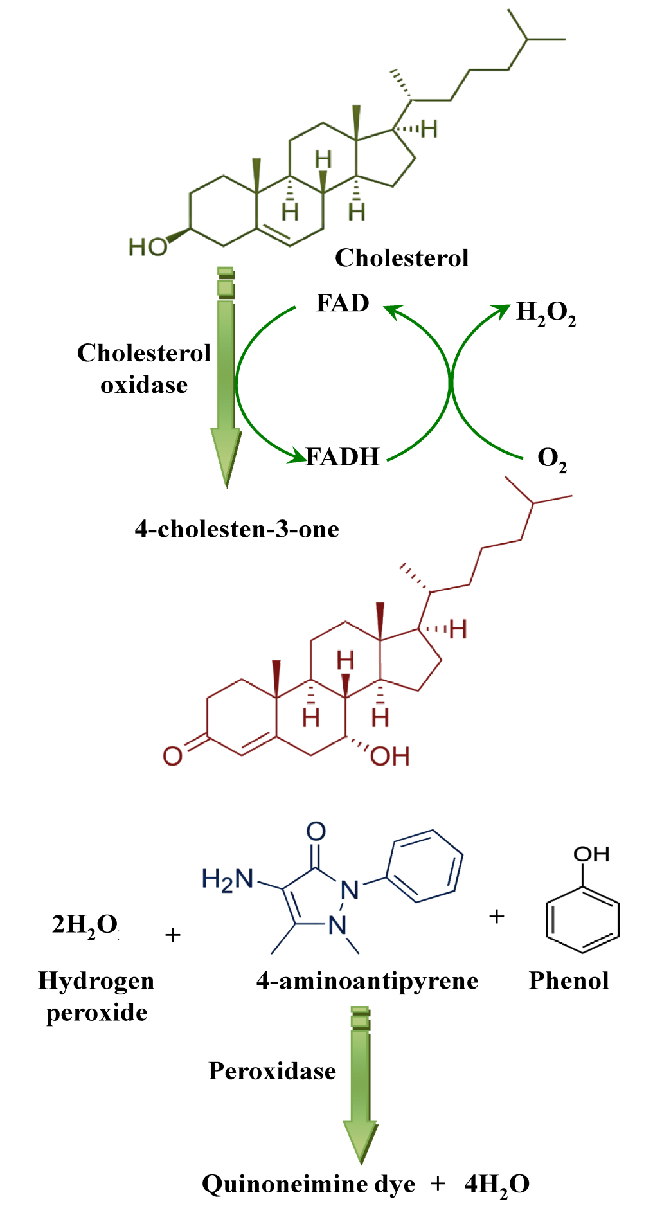
Supplementary Figure 1. Mechanism of reaction catalyzed by cholesterol oxidase.

